Supplementary Materials for

Near perfect microlenses based on graphene microbubbles

Han Lina*, Scott Frasera, Minghui Hongb, Manish Chhowallac, Dan Lid,e and Baohua Jiaa*

aCentre for Micro-Photonics, Faculty of Science, Engineering and Technology, Swinburne University of Technology, P.O. Box 218, Hawthorn VIC 3122, Australia.

bDepartment of Electrical and Computer Engineering, National University of Singapore, 4 Engineering Drive 3, Singapore 117576

cMaterials Science and Engineering, Rutgers University, 607 Taylor Road, Piscataway, New Jersey, USA.

dDepartment of Chemical Engineering, University of Melbourne, Melbourne, VIC 3010, Australia

eDepartment of Materials Science and Engineering, Monash Centre for Atomically Thin Materials, Monash University, Clayton, VIC 3800, Australia

*Han Lin, E-mail: [hanlin@swin.edu.au](mailto:hanlin@swin.edu.au)

*Baohua Jia, E-mail: [bjia@swin.edu.au](mailto:bjia@swin.edu.au).

# S1 Materials and methods

GO film preparation. The aqueous GO dispersion was synthesized by the chemical oxidization of graphite via the modified Hummers Method[26]. Then homogenous GO thin films with controllable thicknesses were prepared by the spray method with a commercially available spray gun (BLACK RIDGE®, professional Air Brush Kit) with a nozzle size of 170 µm on a cover glass substrate. During the spray process, the substrate was placed on a hot plate at 70°C for quick drying of the solvent and without reducing the GO film. To ensure the high uniformity of the film, the distance between the nozzle and the substrate is set to be 10 cm leading to a circular spayed area with a diameter of 5 cm much larger than the size of the cover glass (2.2 cm). The central uniform sprayed area is applied. The nozzle was scanned at a speed of 2 mm/s back and forth across the substrate. Generally low concentration solutions lead to a better uniformity in the sprayed area due to the less chance of the GO particle aggregation. However, it requires a long spray time to achieve the required thickness. We find that when the concentration of the solution is lower than 3 mg/ml, no observable aggregation could be identified. Therefore, 3 mg/ml is used. The overall thickness depended on the amount of GO per unit area. A solution of 6×10-4 mg/mm2 was required to achieve a targeted thickness of 1 µm. The thickness of the prepared film was confirmed by optical profilometry.

Microbubble generation via photo-reduction. A femtosecond laser beam (Libra, 100 fs pulse, 10 kHz repetition rate, 800 nm wavelength) going through the dichroic mirror was focused by a high numerical aperture (NA) objective lens (100×, NA=0.95) onto the GO film through a cover glass. The sample was illuminated from the back using a red (650 nm wavelength) light emitting diode (LED), the light was collected by an optical microscopy imaging system composing of an objective and other lenses (focal length of 200 mm) and imaged onto a CCD camera (Supplementary Fig. S1). The sample was mounted on a 3D nanometric piezo stage (Physik Instrumente®). A computer-controlled system was used to control the parameters of the laser photo-reduction process, including laser power, scanning speed and patterns. The threshold power of the reduction was found to be 5 µW that corresponds to the pulse energy of 0.5 nJ, and the laser started ablating the film when the power was higher than 40 µW (4 nJ pulse energy). The two powers define the lower and upper limits of the reducible laser power range, between which 5 µW steps were taken. The diameter of the laser focal spot was 500 nm. Therefore, the laser energy density in the centre of the focal spot ranged from 0.2 J/cm2 to 1.6 J/cm2. The scanning speed was fixed at 10 µm/s to ensure smooth line fabrication. It was found that the high-quality microbubbles can always be generated if the laser focus is controlled at the interface and the laser power is within the photo-reduction and damage threshold.

# S2. In-situ generation of elastic microbubbles

Generating microbubbles in GO material needs two prerequisites: 1) Produce significant amount of gases from the reduction process within a short period of time so that a strong force can help to detach the GO film from the substrate; 2) Effectively capture the gases between the GO film and substrate in a finite area. According to the numerical modelling, the high energy pulses of a femtosecond laser (800 nm wavelength, 100 fs, 10 kHz repetition rate) is able to dramatically increase the temperature in the focal region of a tightly focused objective (volume of the focal region= 0.53 μm3) to approximately 3800 K in the first 300 fs during the photo-reduction process of GO. In this process, gas products, including CO, O2 and CO2 are rapidly produced. However, analysing the possible reaction paths (Fig. S1 (b)) suggests CO2 is the dominated end gas product [27] in femtosecond laser reduction due to the ultrahigh temperature involved. The generated gases can be effectively captured between the GO film and substrate because the GO film is impermeable to all the produced gases[28].

Experimental realization of the GO film is based on the spray of aqueous GO dispersion on a pre-processed hydrophilic SiO2 substrate to ensure the film uniformity and the firm attachment of the film to the substrate (see the Experiment Section). The thickness of the GO film is carefully controlled to be around 1 µm.

To generate the microbubbles, a femtosecond laser beam is tightly focused to the interface between the GO film and the substrate (Figure. 1(a)) to ensure the effective capture of the generated gases. The sample is illuminated from the backside using a red light emitting diode (LED, wavelength *λ*=650 nm) and the microbubble generation process is monitored in-situ by a CCD camera (Figure 2 and supplementary movie). Upon high peak power laser pulse radiation, the GO film is rapidly photo-reduced, releasing gas products due to the removal of the OCGs1. The gases are captured between the GO film and the substrate next to the reduction area, creating well-defined microbubbles (Figures. 1(b) and (c)). The diameter *D* and the height *h* of the bubble are defined in Figure. 1(b).

The volumes of the microbubbles were calculated by integrating the area covered by the surfaces. The relationships between the volume and the reduced area and the laser power are shown in Figures 3e and 3f, respectively, and consistently show the parabolic trends. Based on the volumes the number of moles of the gases inside the microbubbles versus the reduced area and laser power can be worked out. Linear relationships are found in both Figs. 3(e) and (f), which suggest the photo-reduction process is a single photon process based mainly on the electronic excitation effect and the electron–hole (*e-h*) recombination-induced thermal effect [29]. During the femtosecond laser photo-reduction the electronic excitation effect is significant in the first several picoseconds. This excitation significantly weakens the C-O electronic bonding near the top of the valence band, leading to an immediate deoxygenation of GO. After sufficient *e-h* recombination (i.e. *t* ≥ 100 ps), normal heat reduction becomes dominant. The mechanism has been confirmed by the first-principle simulation of electron–ion dynamics based on the time dependent density functional theory [30].

Through an ultrasensitive in-situ interferometer based on the Newton’s rings, we are able to accurately map the three-dimensional (3D) surface profiles of the microbubbles and the enclosed gas volume with nanometre and femtolitre accuracy, respectively. Due to the highly symmetric and near perfect spherical curvature of the GO microbubble, we demonstrate, as an example, that it can act as an efficient reflective microlens focusing white light into a diffraction-limited ultra-long photonic jet without chromatic aberration. This is, to the best of our knowledge, the first demonstration of a reflective microlens.

# S3. Reduction area dependence

The size of the bubbles can be controlled by the amount of gas being generated, which is controlled by reduced area. In this experiment, we varied the area from 5 μm2 to 25 μm2, and the size of the bubble increased accordingly.

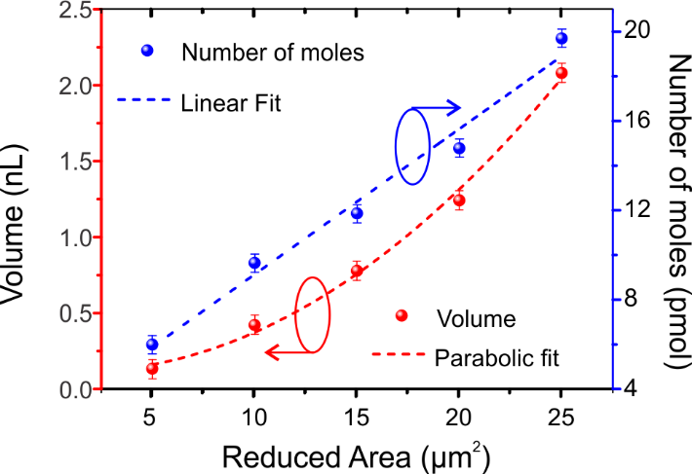

Fig. S1 Volume of the bubble and number of moles of the gases in the bubble versus the reduced area. The area is tuned from 5 μm2 to 25 μm2.

# S4. Power dependence

The size of the bubbles can be controlled by the amount of gas being generated, which can be controlled by the laser power. In this experiment, we varied the power from 5 μW to 40 μW, and the size of the bubble increased accordingly.

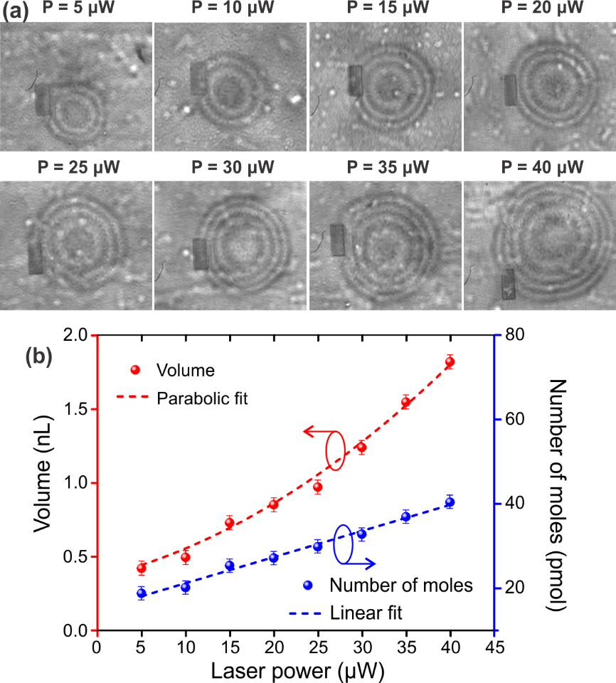

Fig. S2 (a) In-situ optical microscopic images of microbubbles generated with different laser powers for the same reduced area. (b) Volume of the bubble and number of moles of the gases in the bubble versus the laser power. The power is tuned from 5 μW to 40 μW.

# S5. Measured optical constants of graphene oxide and reduced graphene oxide

The optical properties of the graphene oxide and reduced graphene oxide was characterized by a spectral ellipsometry (M-2000 J.A. Woollam Co).

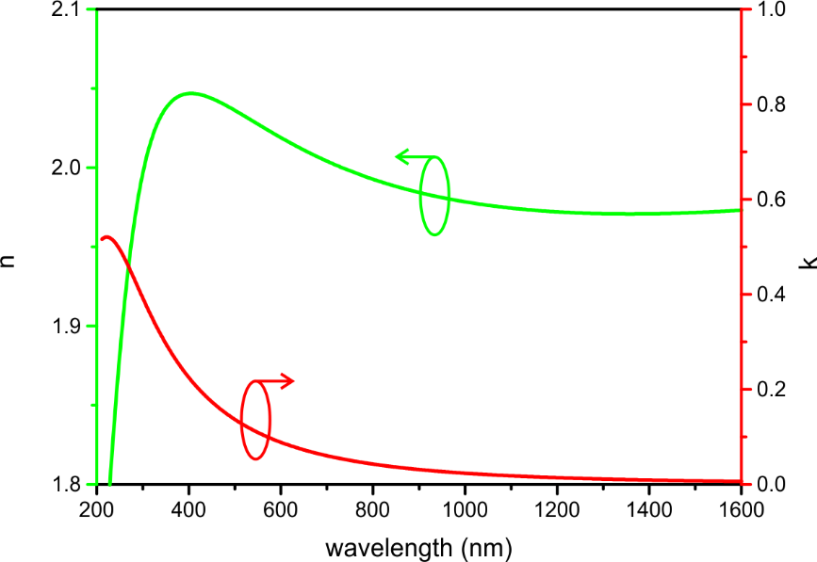

Fig. S3 measured refractive index *n* and extinction coefficient *k* for graphene oxide

RGO

Fig. S4 measured refractive index n and extinction coefficient k for reduced graphene oxide

# S6. Bubble surface curvature fitting

In order to study how close the surface curvature of the microbubble to a perfect spherical surface, we plot the surface curvature (Fig. S5) and fit it with a perfect circle. The example shown here is the bubble from the reduction area of 25 μm2 (A25). As one can see the measured curvature matches very well with a curve of a perfect circle confirming the near perfect spherical surface.

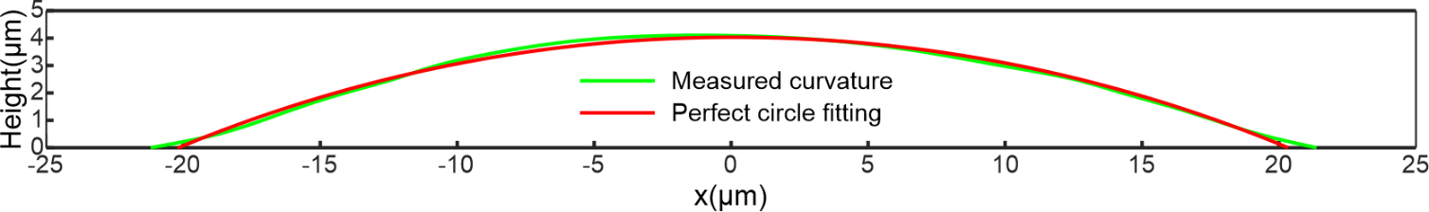

**Fig. S5** Surface curvature plot the microbubble and the fitting with perfect circle function

# S7. Raman spectra of GO and RGO

Raman measurements were performed with a 514 nm continuous laser excitation by using the confocal Raman spectroscope (Renishaw InVia). The laser power at the sample was restricted to 0.5 mW to avoid reduction and the laser beam was focused to a 1 µm diameter spot with a 50× objective lens. The overall integration time was 10 s. Raman spectra were captured from the centre of the photo-reduced area and unreduced GO film for comparison. The Raman spectra show the decreased ID to IG ratio after photoreduction, confirming the decrease of the defect domain and recovery of sp2 carbon network. In addition, the 2D band strength is significantly increased, confirming the formation of graphene domain.

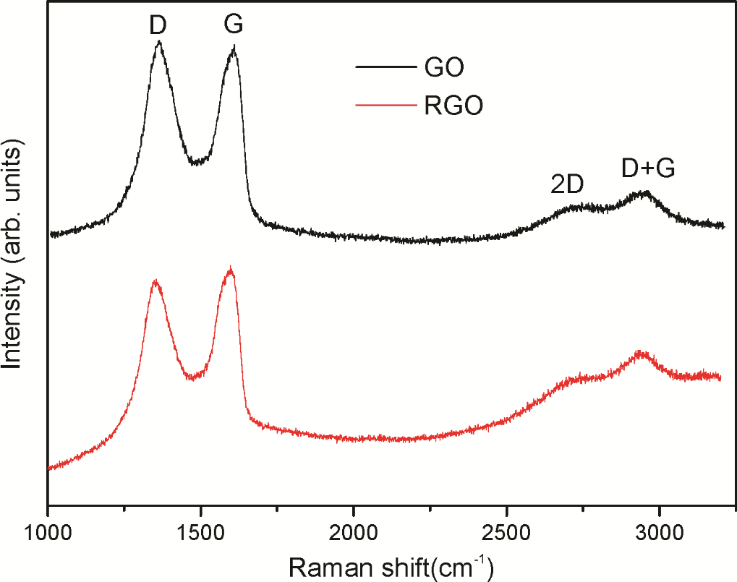

Fig. S6 Raman spectra of GO and RGO

# S8. Stability of the GO microbubble

The stability of the bubble is tested continuously in 24 hours, no noticeable change can be identified.

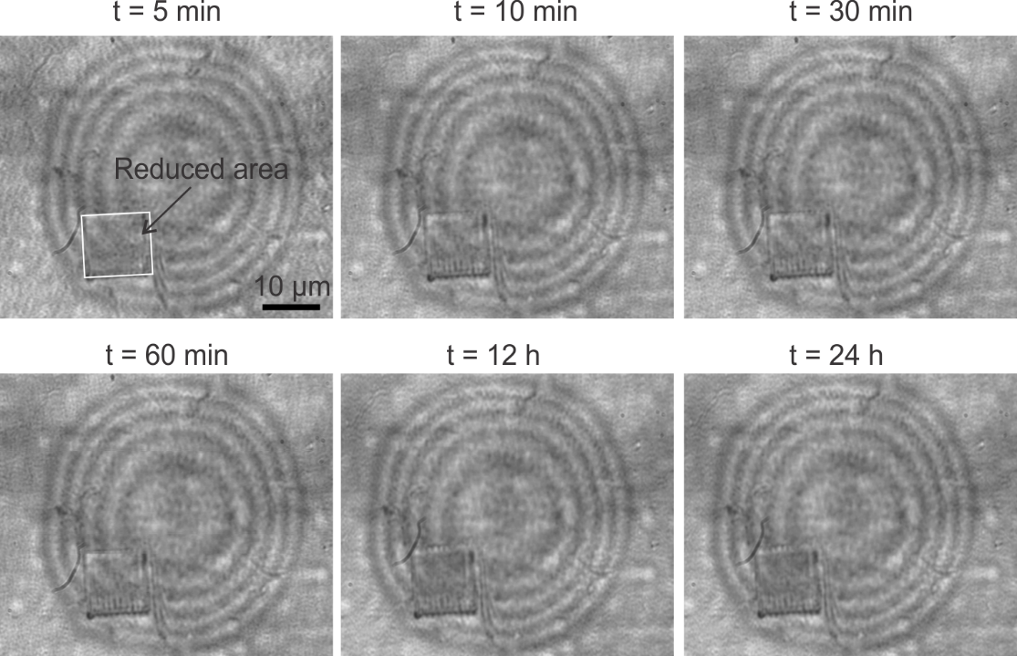

Fig. S7 Images of stable GO microbubble at different times up to 24 hours.

# S9. Laser focus characterization

The measured FWHM in the *y*-direction and *z*-direction are 1.26 µm (Fig. S7(c)) and 38 µm (60λ, Fig. S7(d)), respectively. Through reconstructing the layer-by-layer focal distributions, one can see clearly that nice and smooth focal spot can be achieved at each intensity level (Supplementary Fig. S7(e)), showing the focusing performance of the GO microbubble. It is worth mentioning that the aspect ratio of the focal spot can reach a high number of 30, which shows the properties of a photonic jet [23]. The photonic jet is able to provide high resolution image over a large depth of focus [31] promising broad applications in imaging and sensing. However, until now the demonstration of a photonic jet has only been limited to micro spheres[23,24,31], which are intrinsically challenging to integrate with lab-on-a-chip devices. Here we demonstrate a unique approach to create photonic jet by exploiting the near perfect spherical surface of the GO microbubbles that is flexible to integrate with any substrates and being generated on demand.

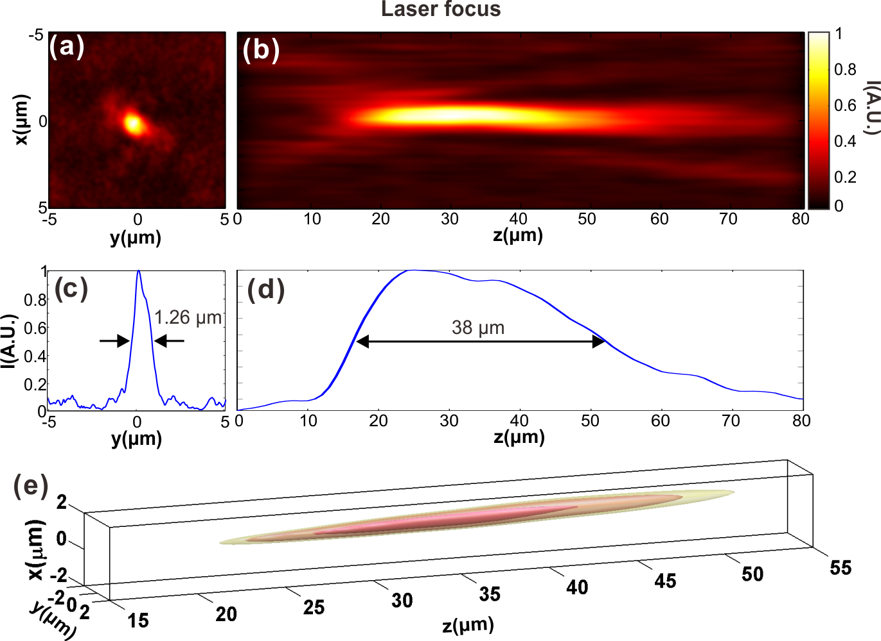

Fig. S8 Focusing characterization of graphene bubbles illuminated by He-Ne laser. Intensity distribution of the bubble microlens in the x-y focal plane (a) and x-z focal plane (b) illuminated by a He-Ne laser beam, and the intensity plots along the y-direction (c) and z-direction (d). (e) The surface plot of the 3D focal spot, the contours from the inside corresponds to the intensity of 0.8, 0.6 and 0.5 of the normalized peak intensity in the focal region.

# S10. Measure the focal length and the numerical aperture of the microlenses fabricated by different laser power and reduced area

As shown in Fig. S8, the focal length *f* can be tuned from 45 µm (71 λ) to 80 µm (126 λ) in a linear manner by controlling the reduced area with the NA remains unchanged (~0.27) due to the same focusing convergence angle. On the other hand, by tuning the laser power from 5 µW to 40 µW, the focal length varies from 45 µm (71 λ) to 101 µm (160 λ) with a similar NA (~0.27 in Fig. S8).

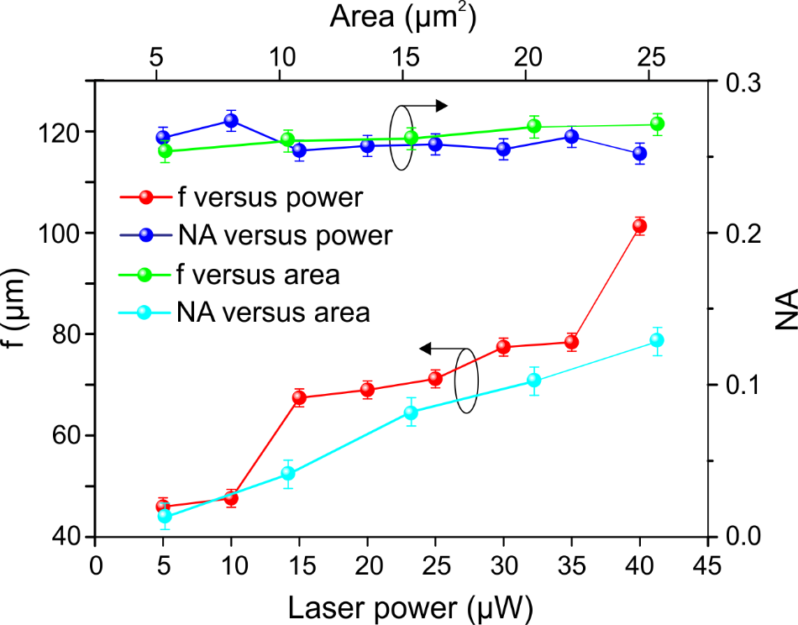

Fig. S9 Focal length and NA dependence on the reduced area and laser power.